

**T-Shirt Request Form**

**Front View**

**Loving My Body P.H.A.T.**



**Physically Healthy And Toned**

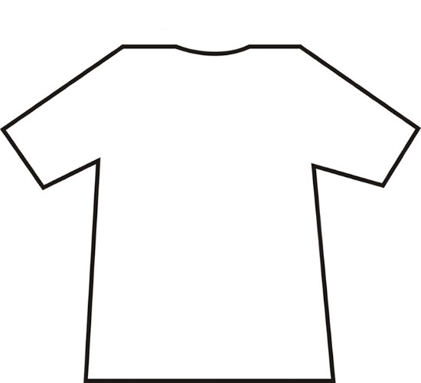

**Back View**

**Circle your**

**T-Shirt Color Choices**

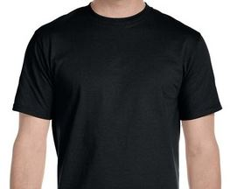 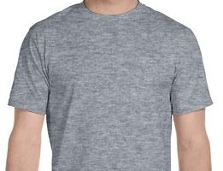 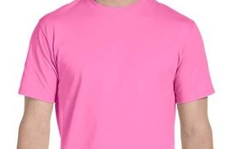

Black/w Grey Fuschia

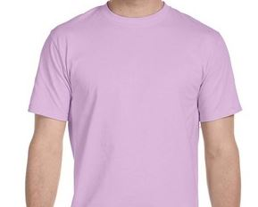 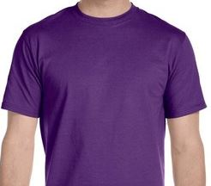 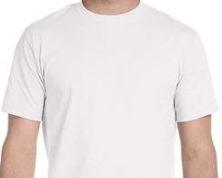

Orchid Purple White



**“Love your body by your own healthy standards”**

[**www.ladybutterflies.org**](http://www.ladybutterflies.org)



**Please indicate your Name and Adult Size: Small, Medium, Large, 1X, 2X**

**_______________________________________________________________________**

**Email order form to Edu_Coordinator@yahoo.com ** Questions? Call 678-902-5239**